**Assignment -3**

Digital Marketing

|  |  |
| --- | --- |
| Student Name | Jothi Anantha Kumar D |
| Student Roll Number | 20URCS018 |
| NM ID | 9EEA217E4294145B2C0498F030D9E2DC |
| College Name | AAA College of Engineering and Technology |

**QUESTION:**

**Create and design a social media advertisement poster using canva.**

**SOCIAL MEDIA ADVERTISEMENT POSTER USING CANVA:**

**Poster link:**

<https://www.canva.com/design/DAFr-HRNyUY/4tdDoCFG-n7DC9FyYHTfBw/edit?utm_content=DAFr-HRNyUY&utm_campaign=designshare&utm_medium=link2&utm_source=sharebutton>

**PosterTitle: CNC LATHE MACHINE**

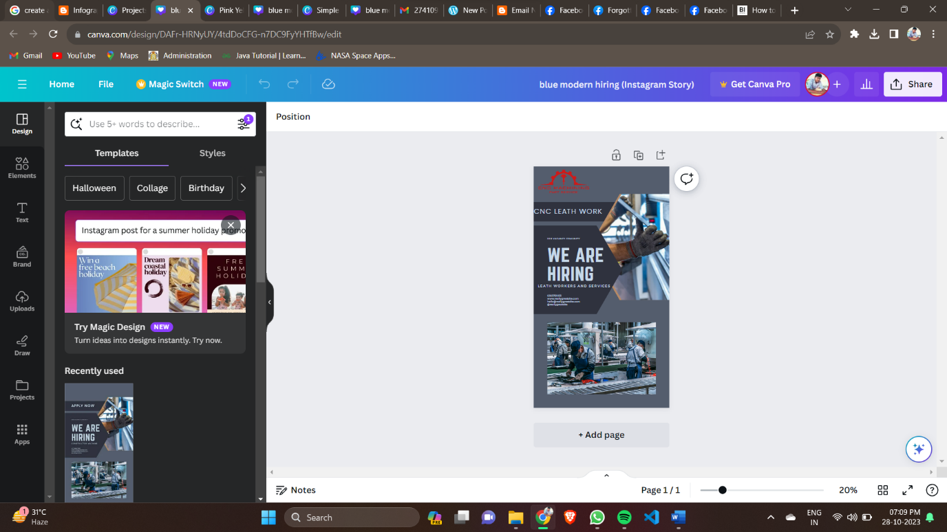

**Poster Image:**

